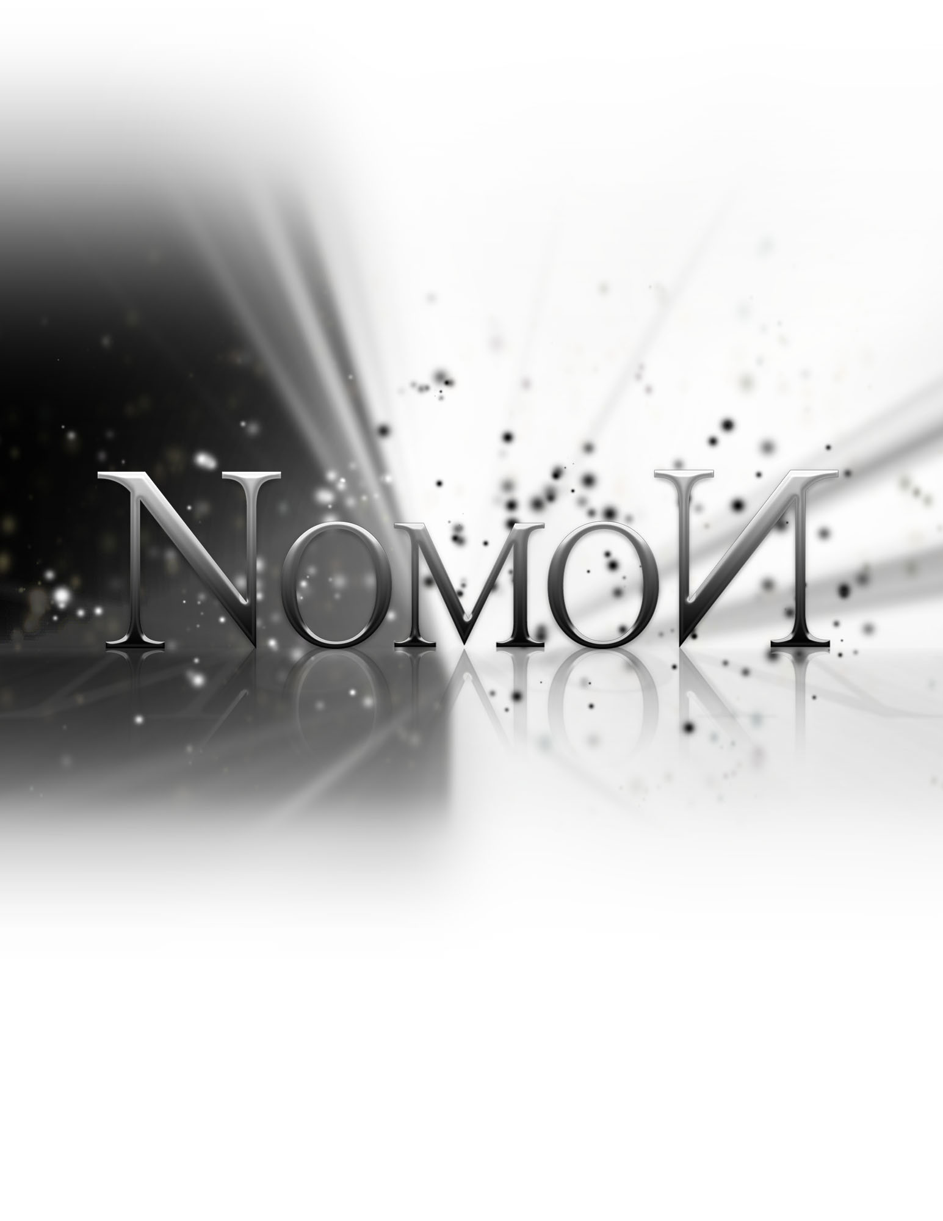
Post-Mortem Report

Friday, December 16, 2011

Project Overview

Tasks Completed

Art

Concept Art - 100% Complete
Worked on by Sarah (20%), Shaughn (30%), Adam (10%), Tom (10%)

Art Research - 100% Complete
Sarah (40%), Shaughn (60%)

Promo Material – 100% Complete
Sarah (85%), Shaughn (15%)

Assets

Modelling - 100% Complete
Tom (5%), Sarah (10%), Shaughn (60%), Adam (25%)

Character Rigging - 100% Complete
Sarah (100%)

Animation – 100% Complete
Sarah (100%)

Other Skinning & Skeletons – 100% Complete
Sarah (100%)

Levels

Level Design – 100% Complete
Adam (40%), Nik (20%), Tom (20%), Sarah (20%)

Puzzle Design – 100% Complete
Adam (40%), Sarah (20%), Tom (10%), Shaughn (10%), Nik (20%)

UDK

Platformer Tutorial - 100% Complete
Nik (30%), Adam (30%), Tom (40%)

Level Building - 100% Complete
Tom (25%), Nik (20%), Sarah (10%), Shaughn (45%)

UDK Custom Character – 100% Complete
Tom (50%), Sarah (50%)

UDK Custom Classes – 100% Complete
Tom (75%), Adam (10%), Shaughn (15%)

UDK Level Transitions – 100% Complete
Tom (50%), Sarah (50%)

Sound and Music – 100% Complete
Shaughn (100%)

Shaders & Post-processing – 100% Complete
Tom (10%), Shaughn (90%)

UDK Custom Menus – 100% Complete
Nik (90%), Sarah (10%)

UDK Custom Physics Objects – 100% Complete
Adam (40%), Shaughn (60%)

Other

Web Design - 100% Complete
Shaughn (50%), Sarah (20%), Adam (30%)

Web Development – 100% Complete
Shaughn (30%), Adam (70%)

File Organization – 100% Complete
Adam (50%), Tom (50%)

Server Management & Debugging – 100% Complete
Adam (100%)

Alpha Testing – 100% Complete
Sarah (40%), Adam (15%), Tom (15%), Nik (15%), Shaughn (15%)

Feature List

- 3D Graphics
- Side-scrolling navigation
- Platforming controls (move, jump, push)
- Moveable objects (statues, wheels)
- Light mechanics
- Hazards (spikes, enemies)
- Stunning visual style
- Atmospheric music and sounds
- Multiple levels
- Menus

Final Deliverables

- Nomon Game Executable (for PC)
- Assets
  - 2D, 3D, Audio
- UDK Source Code
  - Class Files
  - Flash Files
- Promotional Materials
  - Poster
  - Videos
  - Website (www.nomon-game.com)
- Documentation
  - Concept Document
  - Project Plan
  - Design Document
  - Status Reports
  - Post-mortem Report

Process Evaluation

What Went Right

Graphics & Visual Style
Thanks to UDK’s graphics capabilities, we were able to produce many beautiful post-processing effects to achieve a unique and interesting look for the game. Many models were created to add interest to the levels. Particles and other effects were used to highlight significant game components. UDK’s powerful light engine casts rays over the whole game.

Harold
While a lot of internet resources were confusing or not applicable, our friend Harold – an experienced UDK developer – was able to provide insight to many problems and suggest solutions throughout the process. His assistance was invaluable.

Creativity & Flexibility
Level design encountered a lot of obstacles, but the designers were able to work around these. If one puzzle mechanic didn’t work out in UDK, an alternative was produced quickly that kept the spirit of the original design. In total, many different designs were created than were implemented in the final version.

What Went Wrong

Time Management
This semester was an ongoing battle between three courses, each vying for priority. As such, the DS4 term project was never able to receive as much attention as we could have hoped. In the end, the group ended up having to triage projects.

Server Issues
Unfortunately the server hosting our repository started having a lot of difficulties as time went on and files grew larger. A lot of time was spent having to repair the repo and deal with server issues.

Thwarted Level Design
Many different level ideas were created initially, before we knew any of the limitations of UDK. Once these limitations started to crop up, levels had to be modified on the fly, abandoned completely and/or drawn up from scratch, based on input from the programmers. Concepts that were straight forward on paper were often a nightmare in UDK.

Feature Creep
Many new puzzle ideas were introduced late-game, which leveraged previously unexplored aspects of UDK. This introduced a lot of problems and forced our programmers to build and test prefabs when we should have been building and testing levels.

Performance Testing
Due to the limitations of the lab computers, all game development was completed and tested on more powerful home computers and laptops. As such, the game has only been tested on these more optimal conditions and performance suffers on the lab machines.

Risk Management

Limited Knowledge of Tools
We chose to go forward with UDK despite having absolutely no knowledge of it at the start. While we learned a great deal in the process, there was very unequal knowledge transfer between group members, resulting in two of us being relative experts, one of us being very competent, and the other two less useful. It was also difficult to find specific resources when issues were encountered at times. However, UDK had a lot of built-in functionality that the group was able to leverage. The Kismet system enabled group members who don’t normally program much to actually control a lot of the game logic, so we still feel it was the right choice for the job.

Private Server
By choosing to use a private server instead of a school server to host the project repository, we took on the additional burden of having to manage the server ourselves. The advantage of the private server was that when issues were encountered, we were able to fix them ourselves quickly instead of having to contact a third party. This worked out well, because many issues were encountered due to the large repository size. However, it remains unknown (however, we think it was likely) whether these issues would have cropped up when using the school server.

Conclusions

Though many issues were encountered throughout the process, this project was largely fun to create and we are quite happy with the results – though as always, a little more polishing would’ve always been great. We learned a lot about repositories and file management, and tons about UDK. Overall, this project was quite successful and has ended. It is finished now.

Thank you. Happy holidays.

Ship it!

